Appendix 2 - Extract of the updated Policies Map

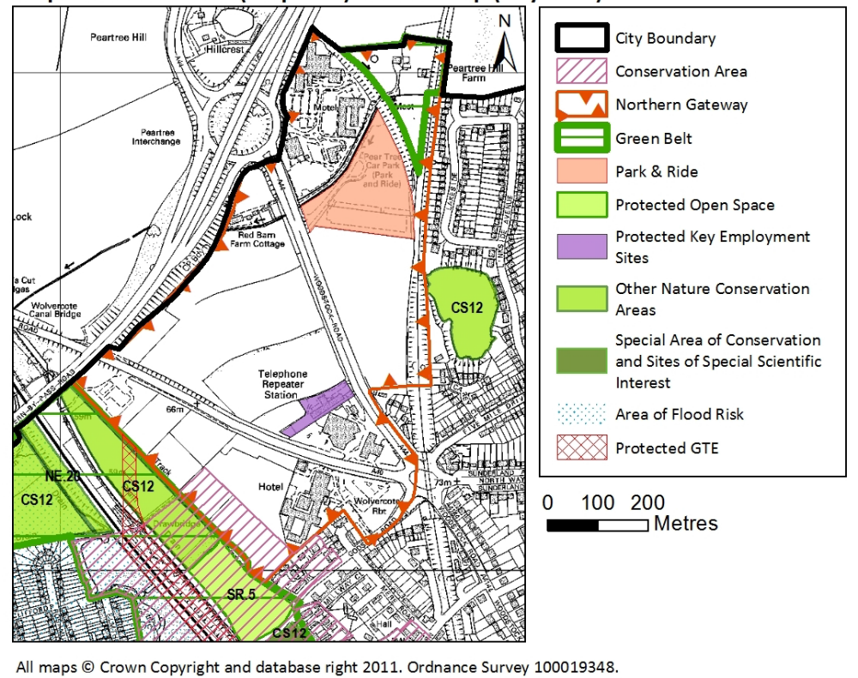
Appendix 3 – Risk Register

 |  |  |  |  | Date Raised | Owner | Gross |  | Current |  | Residual |  | Comments | Controls
Title | Risk description | Opp/ threat | Cause | Consequence | Date Raised | Owner | I | P | I | P | I | P | Comments | Control description | Due date |  | Status |  | Progress % |  | Action Owner
Legal challenge | High Court challen-  ge - the process and time-scale for which are summar-ised in the report | Threat | Aggrieved person(s) who are unhappy with the adopted AAP may decide to exercise their right to apply for a judicial review. In order for a legal challenge to be successful, the High Court would have to be satisfied that the plan is to any extent outside the appropriate power, and/or that the interests of the applicant have been substantially prejudiced by a failure to comply with a procedural requirement | If successful the High Court would rule that the AAP be quashed, wholly or in part | 18.6.15 | Head of Planning and Regulat-ory | 4 | 3 | 4 | 2 | 4 | 2 | Officers consider that the relevant statutory proced-ures have been met during the preparat-ion of the AAP | The examinat-ion was conducted by an indepen-dent planning inspector |  | Period for challe-nge ends six weeks from adopt-ion (Sund 30th August 2015) |  | On-going |  |  | Head of Planning and Regula-tory Services

